The Second International Symposium on Hydraulic Modeling and Measuring Technology

Symposium Program


Scan to visit our homepage
- May 30 - June 1, 20182018
- Nanjing, China

About

Water resources and hydropower projects have been increasingly built in recent years, which strongly promotes the progress of the modeling and measuring technology in the fields of hydraulic engineering, river and water ecologic environment. The International Symposium on Hydraulic Physical Modeling and Field Investigation (ISHPF2010), hosted by Nanjing Hydraulic Research Institute (NHRI), was successfully held in 2010 in Nanjing, China, setting up a unique platform for technical exchange and demonstration of the development and new ideas of hydraulic physical modeling and field investigation technology.
In order to fully make insights into the frontier trends and latest development of the recent modeling and measuring technology of hydraulic engineering, NHRI, International Association for Hydro-Environment Engineering and Research (IAHR) and Hohai University (HHU) jointly organize the Second International Symposium on Hydraulic Modeling and Measuring Technology in Nanjing, China during May 30-June 1, 2018. With the theme “Important Role of Modeling and Measuring Technology in Water Science Research”, this symposium aims to share the latest achievement in scientific research including hydraulic physical modeling, numerical modeling, field investigation and measurement instruments by both Chinese and foreign experts.

Organizers
Nanjing Hydraulic Research Institute (NHRI)
International Association for Hydro-Environment Engineering and Research (IAHR)
Hohai University (HHU)

Co-Organizers
International Joint Research Center of Water Science and Engineering, MoST, China
State Key Laboratory of Hydrology-Water Resources and Hydraulic Engineering, China
IAHR Experimental Methods and Instrumentation Committee (EMI)
Chinese Hydraulic Engineering Society
China Society for Hydropower Engineering
Key Laboratory of Water Science and Engineering, MWR, China
Key Laboratory of Navigation Structures, MoT, China
Key Laboratory of Port, Waterway and Sedimentation Engineering, MoT, China
R&D Center of Hydro-Power Engineering Safety and Environmental Technology of NEA, China
National Engineering Research Center of Dredging Technology and Equipment, China
Hydraulic Measurement Technical Committee of Chinese Hydraulic Engineering Society, China
Navigation Engineering Committee of Chinese Society for Hydropower Engineering, China
Beijing SINFOTEK Information Technology Co., Ltd.

Supports
Water Resources Efficient Utilization Projects of the National Key Research and Development Program of China (Project No.: 2017YFC0404600 & 016YFC0401500)
Special Project of Water Pollution Control and Treatment of the National Science and Technology Major Special Projects (Project No.: 2017ZX0703002)
Journal of Hydraulic Research
Water Science and Engineering
China Ocean Engineering
Journal of Hydrodynamics
Advances in Water Science
Hydro-Science and Engineering

Sponsors
Nanjing Hawksoft Technique Co. Ltd.
Nanjing Tianfu Software Co. Ltd.
Nanjing SURE Tech. & Dev Co. Ltd
Nanjing Bosen Technology Co., Ltd.
Shanghai P-NAV Tech. Co., Ltd.
Shanghai Zealquest Science & Technology Co. Ltd.

Theme
Important Role of Modeling and Measuring Technology in Water Science Research

Topics
1. New Technology for Physical and Hybrid Modelling of River, Coastal and Environmental Flows
1) Modeling of flow over structures and energy dissipaters
2) Modeling of surface water and groundwater
3) Modeling of sediment transport and fluvial processes
4) Modeling of estuarine and coastal evolution and wave movement
5) Modeling of hydrodynamics in harbors and ports
6) Modeling of transmission of pollutants, salt, heated flow
7) Modeling technology of dam and dike breach
8) Similarity theory and scale effects of physical modeling
9) Hybrid model approach and combination of physical approaches with numerical simulation

2. Laboratory Measurement Technology
1) Facilities for laboratory measurement
2) Sensor technology and instruments for hydraulic measurement
3) New technology for hydro-environmental and eco-hydraulic measurement

3. Field Measurement Technology
1) Field investigation and experiment in inland waters, estuaries and oceans
2) Field investigation and experiment for hydro-environment, eco-system and river restoration
3) Field investigation under extreme conditions: storm, tsunami, flooding and ice-and-snow disasters
4) Technology of long-term hydraulic monitoring and controlling of hydro-environmental engineering
5) Comparison between laboratory experiments and field investigation
6) Data acquisition and data processing

Academic Committee
Chair
ZHANG Jianyun, Member of the Chinese Academy of Engineering, International Fellow of UK Royal Academy of Engineering, President of Nanjing Hydraulic Research Institute, China

Vice Chairs
Joseph Hun-wei Lee, Fellow of UK Royal Academy of Engineering, Hong Kong University of Science and Technology, Hong Kong, China
Peter Goodwin, IAHR President, University of Maryland, USA
Alessio Radice, Chair of EMI, IAHR, Polytechnic University of Milan, Italy
TANG Hongwu, Chairman of Hohai University Council, China

Members
Prof. Bruce Melville, Fellow of the Royal Society of New Zealand, University of Auckland, New Zealand
Prof. Carsten Thorenz, Federal Waterways Engineering and Research Institute, Germany
Prof. Colin Rennie, University of Ottawa, Canada
Prof. David Zhu, Fellow of Canadian Academy of Engineering, University of Alberta, Canada
Prof. Hubert Chanson, University of Queensland, Australia
Prof. James Ball, IAHR Vice President, University of Technology Sydney, Australia
Prof. James Yang, Royal Institute of Technology, Sweden
Prof. Junfeng Zhu, University of Kentucky, USA
Prof. Ling Li, University of Queensland, Australia
Prof. Marcel R.A. van Gent, Deltares, the Netherlands
Prof. Marcel Stive, Member of Royal Dutch Institution of Engineers (KIVI), TU Delft, the Netherlands
Prof. Ralph S. Budwig, University of Idaho, USA
Prof. Rigo Philippe, University of Liege, Belgium
Prof. Shunqi Pan, University of Plymouth, UK
Prof. Tianqi Ye, University of Arizona, USA
Prof. Tom De Mulder, Ghent University, Belgium
Prof. Xiaonan Tang, University of Liverpool, UK
Prof. DONG Zhiyong, Zhejiang University of Technology, China
Prof. DOU Xiping, Nanjing Hydraulic Research Institute, China
Prof. HU Chunhong, Member of the Chinese Academy of Engineering, China Institute of Water Resources and Hydropower, China

Prof. HU Xunyue, Changsha University of Science and Technology, China
Prof. HUANG Anbin, Chiao Tung University, Taiwan, China

Prof. HUANG Guobing, Changjiang River Scientific Research Institute, China
Prof. JIANG Chunbo, Tsinghua University, China

Prof. JIANG Enhui, Yellow River Institute of Hydraulic Research, China
Prof. LI Yun, Nanjing Hydraulic Research Institute, China
Prof. LIAN Jijian, Tianjin University, China
Prof. PENG Jing, China Institute of Water Resources and Hydropower, China
Prof. WANG Chao, Member of the Chinese Academy of Engineering, Hohai University, China
Prof. WANG Guangqian, Member of the Chinese Academy of Sciences, Tsinghua University, China
Prof. WANG Junxing, Wuhan University, China
Prof. WANG Pingyi, Chongqing Jiaotong University, China
Prof. WANG Zhaoyin, Tsinghua University, China
Prof. WU Jianhua, Hohai University, China
Prof. WU Peng, CCCC Water Transportation Planning and Design Institute Co., Ltd., China

Prof. WU Yihong, China Institute of Water Resources and Hydropower, China
Prof. XIA Jun, Member of the Chinese Academy of Sciences, Wuhan University, China
Prof. XU Weilin, Sichuan University, China
Prof. YAN Genhua, Nanjing Hydraulic Research Institute, China
Prof. ZHANG Cangrong, Taiwan University, Taiwan, China
Prof. ZHANG Huaqing, Tianjin Research Institute for Water Transport Engineering, China

Prof. ZHANG Changkuan, Hohai University, China

Local Organizing Committee

Chair

Prof. LI Yun, Vice President, Nanjing Hydraulic Research Institute

Vice Chairs

Prof. WU Shiqiang, Nanjing Hydraulic Research Institute
Prof. ZHENG Jinhai, Hohai University

Members
CHEN Hong, Senior Experimenter, Hohai University
Prof. CHEN Qiuwen, Nanjing Hydraulic Research Institute
Prof. GAO Changsheng, Nanjing Hydraulic Research Institute
Prof. GUAN Tiesheng, Nanjing Hydraulic Research Institute

Prof. HU Ya’an, Nanjing Hydraulic Research Institute
Prof. PAN Junning, Nanjing Hydraulic Research Institute
Prof. SUN Feng, Nanjing Hydraulic Research Institute
Prof. WANG Lingling, Hohai University
Prof. WANG Xiaogang, Nanjing Hydraulic Research Institute
Prof. WANG Yintang, Nanjing Hydraulic Research Institute
Prof. XIA Yunfeng, Nanjing Hydraulic Research Institute
Prof. XU Shikai, Nanjing Hydraulic Research Institute
Prof. XUAN Guoxiang, Nanjing Hydraulic Research Institute
Prof. YANG Dongli, Nanjing Hydraulic Research Institute
Prof. ZHU Yuliang, Hohai University

Secretariat
Secretary-General
Prof. HU Ya’an, Nanjing Hydraulic Research Institute
Deputy Secretaries-General
LI Jun, Nanjing Hydraulic Research Institute
ZHOU Tiantao, Nanjing Hydraulic Research Institute

Program Overview
Date | Time | Topic | Location
5/29 | 8：00-22：00 | Registration | R&D Hotel  (No.223 Guangzhou Road, Nanjing)
5/29 | 18：00-21：30 | Dinner | R&D Hotel  (No.223 Guangzhou Road, Nanjing)
5/30 | 8：30-9：00 | Opening Ceremony | Multiple-function Hall  (12th Floor, NHRI Water Resources Building, No.225 Guangzhou Road, Nanjing)
5/30 | 9：00-12：00 | Keynotes, part 1
5/30 | 12：00-14：00 | Buffet Lunch | R&D Hotel
5/30 | 14：00-15：30 | Keynotes, part 2 | Multiple-function Hall  (12th Floor, NHRI Water Resources Building,
5/30 | 15：30-15：50 | Tea break
5/30 | 15：50-17：50 | Keynotes, part 3
5/30 | 18：30-20：00 | Reception dinner | R&D Hotel
5/31 | 8：30-17：56 | Parallel Sessions R&D Hotel  Session 1:New technology of hydraulic modeling and measurement I  Session 2: New technology of hydraulic modeling and measurement II  Session 3:New technology of river modeling and measurement I  Session 4:New technology of river modeling and measurement II  Session 5: New technology of water ecological environment modeling and measurement  Tea break  （10：05-10：20）（15：33-15：50）  Lunch break  （12：08-13：45）
5/31 | 18：30-19：30 | Dinner R&D Hotel
5/31 | 19：30-21：00 | Annual Meeting of IAHR China (Mainland) Chapter  International Conference Hall  (13th Floor, NHRI Headquater Building,  No.223 Guangzhou Road, Nanjing)
6/1 | 8：30-10：10 | Visit to Sluice Project of the Sanchahe River Estuary
6/1 | 10：10-11：50 | Visit to Water Experiment Center of NHRI at Tiexinqiao
6/1 | 12：00-13：00 | Lunch NHRI Water Experiment  Center at Tiexinqiao

Keynotes
Date: May 30, 2018
Venue: Multiple-function Hall, 12th Floor of Water Resources Building, NHRI
(No. 225 Guangzhou Road, Nanjing)

Opening Ceremony
Time | Topic |  |  |  | Chair
08:30-09:00 | 1. Opening introductions  2. Welcome speech by Li Yun, Vice President, NHRI  3. Addresses by James Ball, Vice President, IAHR |  |  |  | Prof. Wu Shiqiang,  Director,  NHRI Hydraulic Engineering Department
Keynote Presentation (Part 1)
Time |  | Topic | Speaker |  |  | Chair
09:00 - 09:30 |  | The importance of field monitoring urban catchments | Prof. James Ball  Vice President, IAHR |  |  | Prof. Zheng Jinhai  Vice President, Hohai University  Prof. Alessio Radice,  Chair, IAHR EMI Committee
09:30 - 10:00 |  | Innovative technology of island and tunnel engineering of Hong Kong-Zhuhai-Macao Bridge | Prof. Lin Ming,  Project General Manager of Island and Tunnel Engineering of Hong Kong-Zhuhai-Macao Bridge, China
10:00 - 10:30 |  | Tea break
10:30 - 11:00 |  | Seeing through and around the sediment bed; applying the refractive index matching method to unveil complex hydraulic and hypothetic processes |  | Prof. Ralph S. Budwig,  University of Idaho, USA |  |  | Prof. Zheng Jinhai  Vice President, Hohai University  Prof. Alessio Radice,  Chair, IAHR EMI Committee
11:00 - 11:30 |  | Application and practice of large-scale hydraulic simulation technology in the research of flood discharge and energy dissipation of high dams |  | Prof. Li Yun  Vice President, NHRI
11:30 - 12:00 |  | The role of physical and numerical modeling in experimental hydraulics in Spain and Europe |  | Dr. Luis Balairon Perez, Polytechnic University of Madrid, Spain
12:00–14:00 |  | Lunch break

Keynote Presentation (Part 2)
Time | Topic | Speaker | Chair
14:00 - 14:30 | Technologies of measurement and control for physical models of plain rivers and its application | Prof. Tang Hongwu,  Chairman, Hohai University Council, China | Prof. James Ball,  Vice President, IAHR  Prof. Wang Xiaogang, Deputy Director, NHRI Hydraulic Engineering  Department
14:30 - 15:00 | Bridge pier scour in live-bed: from a case-study prototype to an investigation of the process | Prof. Alessio Radice,  Chair, IAHR-EMI Committee
15:00 - 15:30 | TBC | Prof. Liu Zhiping, Vice President, China Institute of Water Resources and Hydropower Research, China
15:30 - 15:50 | Tea break

Keynote Presentation (Part 3)
15:50 - 16:20 | Growing challenges in river engineering - What contribution can hybrid modeling make | Dr. Sven Wurms,  Federal Waterways Engineering and Research Institute, Germany | Prof. James Ball,  Vice President, IAHR  Prof. Wang Xiaogang, Deputy Director, NHRI Hydraulic Engineering  Department
16:20 - 16:50 | Experimental investigation of meso-hydraulic characteristics of cavitation and its damage | Prof. Xu Weilin  Vice President, Sichuan University, China
16:50 - 17:20 | Combination of numerical and physical models for optimal spillway performance | Dr. Jonas person,  Norconsult, Sweden
17:20 - 17:50 | Water and Sediment Monitoring and Control Technology and Its Application in the River Model | Pro. Xia Yunfeng,  Deputy Director, NHRI River Harbor Engineering Department, China

Parallel Sessions

Session 1 New technology of hydraulic simulation and measurement I
Date: May 31, 2018
Venue: Multiple-Function Hall (3rd F, R&D Hotel)
Time | Topic |  | Reporter | Chair
08:30 - 08:35 | Opening Speech
08:35 - 08:53 | CFD modeling of a tangential vortex intake using OpenFOAM |  | Shu Ning Chan
08:53 - 09:11 | A numerical investigation of Reynolds number effects on the wind loads on cylindrical roofs |  | Tokiniaina Ricky Rajaoarimanga | Jing Peng
09:11 - 09:29 | Scale-effect of flow-field and sediment size on scour at bridge pier with simple and complex pier geometry |  | Yifan Yang | IWHR
09:29 - 09:47 | A combined hydrological and hydraulic model for flood prediction in South-Eastern hilly regions of Bangladesh applied to the Sangu River Basin |  | Arup Chakraborty
09:47 - 10:05 | Study on the flow characteristics of resting pools in vertical slot fishway |  | Xiaogang Wang
10:05– 10:20 | Tea break
10:20 - 10:38 | Analysis of the mixing in the shallow and subtropical Tingalpa reservoir, Australia |  | X.Wang
10:38 - 10:56 | Experimental study on hydrodynamic performance of baffle drop structures |  | Wenchuang Chen
10:56 - 11:14 | Prototype observation on the mechanical characteristics of the chamber anti-collision device of large ship lifts |  | Xin Wang
11:14 - 11:32 | Features of approaching flow upstream of cylinders in tandem arrangement based on PIV measurement |  | Pingping Yang | Stefan Geert  FHR
11:32 -11:50 | Fluid-Structure Interaction study on hydraulic features of the whole fluid flow in a vertical axial pump and vibration performance of its blades |  | Yin Guojiang
11:50-12:08 | Study on the design transit capacity of inland waterways for mixed ship traffic |  | Liangde He
12:08 - 13:45 | Lunch
13:45 - 14:03 | High-precision synchronous UTTM measuring system for flow depth and discharge in open channels |  | Zhigang Wang
14:03- 14:21 | Operating behavior of Longma CFRD based on dam safety monitoring data |  | Serges Mendomo Meye
14:21 - 14:39 | Study on layout pattern of filling and emptying systemin Datengxia Shiplock |  | Yingzhuo Wu | Jianhua Wu
14:39 - 14:57 | Applying artificial neural networks algorithms to rainfall-runoff modeling - (case study Jhelum river basin) |  | Abdul Qayoom Dar | Hohai University
14:57 - 15:15 | A novel wireless photoelectric propeller flow meter based on ZigBee digital transmission technology |  | Jun Wu
15:15 - 15:33 | Experimental aeration study on control valve of hydraulic driven shiplift |  | JiaoWang
15:33 - 15:50 | Tea break
15:50- 16:08 | Analysis of longterm hydrological changes induced by anthropogenic and climatic changes in the Guanting basin using the SWAT model | Gebdang B. Ruben
16:08-16:26 | Dam break simulation by Weakly Compressible Smoothing Particle Hydrodynamic (WCSPH) method | Congfang Ai |  | Niansheng Cheng  Nanyang Technological University
16:26-16:44 | Applying SMOS soil moisture data into the HBV distributed hydrologic model for flash flood | Nguyen Ngoc Tu |  | Niansheng Cheng  Nanyang Technological University
16:44-17:02 | Comparison of methods of determining bed shear stress in duct flows | Dake Chen |  | Niansheng Cheng  Nanyang Technological University
17:02-17:20 | Research on the design method of large - scale artificial waterway | Fengshuai Cao
17:20-17:38 | The feature extraction and model establishment of dam based on 3D laser scanning technology | Hou Ma
17:38-17:56 | Research on the design of the scouring system on large span under horizontal rotation gate | Xianrui Shi

Session 2 New technology of hydraulic modeling and measurement II
Date: May 31, 2018
Venue: Meeting Room 6 (3rd F, R&D Hotel)
Time | Topic | Reporter | Chair
08:30 - 08:35 | Opening Speech
08:35 - 08:53 | Modelling of air demand of a spillway aerator with two-phase flow models | James Yang
08:53 - 09:11 | Incipient sediment motion in the presence of large-scale roughness | Niansheng Cheng | Zhiyong Dong
09:11 - 09:29 | Air demand due to flood discharges at Moforsen dam - CFD modelling with field measurements | Penghua Teng | Zhejiang University of Technology
09:29 - 09:47 | Hydraulic characteristics of free overall in rough and steep rectangular channel | Chao Liu
09:47 - 10:05 | Energy dissipation of skimming flow in ski-jump-step spill way | Shangtuo Qian
10:05– 10:20 | Tea break
10:20 - 10:38 | Performance improvement of headworks: a case of Kalignadaki a hydropower plant through physical hydraulic modelling | Meg B. Bishwakarma
10:38 - 10:56 | Application of LSPIV to environmental flows in laboratory and field cases | Shiping Ruan
10:56 - 11:14 | PIV analysis and high speed photographic observation of cavitating flow field behind circular multi-orifice plates | Zhiyong Dong | James Yang  KTH
11:14 - 11:32 | Flow characteristics and air induction of free-falling water jets of various shapes | Yiyi Ma
11:32 -11:50 | Thermal effect on the failure of hydraulic concrete structures under high velocity flow cavitation | Wenxun Qian
11:50-12:08 | Cavitation-silt erosion with considering viscosity of sand suspensions | Yu Wang
12:08 - 13:45 | Lunch
13:45 - 14:03 | Flow patterns of a plane-boundary-confined propeller jet | Maoxing Wei
14:03- 14:21 | Prediction method of field vibration induced by flood discharge of high dam | Luchen Zhang
14:21 - 14:39 | Study on aeration at valve bottom rim of high-head shiplock | Yingzhuo Wu | Jinyou Lu
14:39 - 14:57 | Mathematical modelling and numerical simulation of damage evolution process caused by inner water penetrating out from cracks of conduits through embankment dams | Qiong Pang | CRSRI
14:57 - 15:15 | Fluctuating pressure characteristics of different flood discharge types in MHSJ stilling basin | Zhipan Niu
15:15 - 15:33 | Numerical analyses of the holistic hydraulic loads characteristics of high water-head plane gate | Jinxiong Zhang
15:33 - 15:50 | Tea break
15:50- 16:08 | Flow separation in the hydraulic-jump-stepped spillway | Yu Zhou
16:08-16:26 | Experimental study on emergency gate hydraulics in high dams | Wenyuan Zhang | Jonas Persson
16:26-16:44 | Numerical simulation study on the aeration and diffusion of aerated water jet based on SPH method | Hua Zhang | Norconsult
16:44-17:02 | Aeration technology for spillway tunnel with high head and large discharge | Dong Zhang
17:02-17:20 | Effect of blade trailing edge position on a pump as turbine (PAT) pressure field under Part-load conditions. | Binama Maxime
17:20-17:38 | Fuzzy clustering prediction on the influnce of high dam discharge given to the habitat of downstream bank | Yongfei Qi
17:38-17:56 | Experiment research and numerical simulation comparison of unsymmetrical y-type penstock for hydraulic loss | Jia Dong

Session 3 New technology of river modeling and measurement I
Date: May 31, 2018
Venue: Meeting Room 4 (3rd F, R&D Hotel)
Time | Topic |  | Reporter | Chair
08:30 - 08:35 | Opening Speech
08:35 - 08:53 | Monitoring streambed elevation continuously |  | Daniele Tonina
08:53 - 09:11 | Sensitivity and precision analysis of an automated grain sizing method for gravel bed |  | Kehan Huang | Pei Xin
09:11 - 09:29 | The effect of bottom slope discontinuity on numerical solution of the Saint Venant equations |  | Ben R. Hodges | Hohai University
09:29 - 09:47 | Development of an autonomous streamgage based on advancedstereo LSPIV techniques |  | Qian Liao
09:47 - 10:05 | Numerical simulation of cross flow fields distribution characteristics of waterway bifurcation region |  | Xue mei Fan
10:05– 10:20 | Tea break
10:20 - 10:38 | Influence of bed elevation discordance onto the flow patterns in an open-channel confluence |  | Pedro Xavier Ramos
10:38 - 10:56 | Observation of Ice regime and safe dispatch research on South-to-North Water Diversion Middle Route project in winter |  | Wengang Duan
10:56 - 11:14 | Effects of flow depth scaling on local scour at submerged weirs |  | Lu Wang | Sven Wurms
11:14 - 11:32 | Control of turbulence characteristics of free surface flow past open channel transitions |  | Samuel Li | BAW
11:32 -11:50 | A study on the coupling simulation technique of waves and tides |  | Maowen Chen
11:50-12:08 | Analysis on adjustment of erosion and siltation of goose head branching channel in lower Yangtze River after three gorges project impoundment |  | Xiaobing Cheng
12:08 - 13:45 | Lunch break
13:45 - 14:03 | Taihu physical model and Taihu mathematical model |  | Yong Wang
14:03- 14:21 | Flood vulnerability analyses using GIS technique: a case study for the 2017 flood event in Bangladesh |  | Mahfuzur Rahman
14:21 - 14:39 | Field measurement of turbidity currents in reservoir and bathymetry analysis |  | Ruidong An | Xiaogang Wang
14:39 - 14:57 | The study for drainage enhancement of the lower Thachin River in Thailand by cut-off |  | Krittikorn Thanawisitsawat | NHRI
14:57 - 15:15 | Flume physical model design and verification of saltwater intrusion |  | Yugui Yang
15:15 - 15:33 | Evolution of wetlands in Dongting lake: a numerical study using a high-resoultion 2D model |  | Dechao Hu
15:33 - 15:50 | Tea break
15:50- 16:08 | Development of desiccation cracks in a physical model of undisturbed expansive clay slope subjected to cyclic wetting and drying | Amenuvor |  | Ralph Budwig
16:08-16:26 | Research and application of bed load transport monitoring system based on image recognition technology | Ang Gao |  | University of Idaho
16:26-16:44 | Comparison of levenberg marquardt and conjugate gradient descent optimization methods for simulation of streamflow using artificial neural network | Bafitlhile Thabo Michael
16:44-17:02 | Application of the orthophoto based UAV technique for flood simulation | Bingyao Li | Jingming Hou
17:02-17:20 | Multiphase sloshing and interfacial wave interaction with a submersed block | Obai Kargbo
17:20-17:38 | Global analysis to transmission coefficient of wave running over submerged rectangle barrier | Zhaobing Jiang
17:38-17:56 | Optimization and analysis research of the rotor velocity meter propeller sensor | Chi Wang

Session 4 New technology of river modeling and measurement II
Date: May 31, 2018
Venue: Meeting Room 5 (3rd F, R&D Hotel)
Time | Topic | Reporter | Chair
08:30 - 08:35 | Opening Speech
08:35 - 08:53 | Shanghai flows: a web-based data-stakeholder interface for water infrastructure policy support; an exploration into international applicability, focus on Shanghai | Ties Rijcken
08:53 - 09:11 | Neural network application study in Sea level estimation in central Viet Nam Coast during storm event | Fumin Xu
09:11 - 09:29 | Flanders maritime laboratory, new large scale facilities for towing tank and wave basin research | Stefan Geerts | Alessio Radice  Politecnico di Milano
09:29 - 09:47 | Simulations of extreme storms on Belgian Coast | Gensheng Zhao
09:47 - 10:05 | Application of data assimilation based on particle filter algorithm on simulating hydrodynamics in the micro-model of the lower yellow river | Minghong Chen
10:05– 10:20 | Tea break
10:20 - 10:38 | Mitigation of tsunami bore induced pressures on a vertical wall with a dike | Zhonghou Xu
10:38 - 10:56 | Experimental study of tsunami bore induced scour at different coastal road orientations | Hamzah Saiful Bahri
10:56 - 11:14 | Experimental study on fluctuation degree and surface form resistance of riverbed | Yinjun Zhou | Gensheng Zhao NHRI
11:14 - 11:32 | Analysis and comparison of calculation methods of friction velocity under equilibrium suspended sediment transport | Dong Chen
11:32 -11:50 | Research on gradation variation of suspended sediment in middle and lower Yangtze river (since 2003) | Yi Liu
11:50-12:08 | Study on the similar scale of the physical model of salt tide | Fei Yuan
12:08 - 13:45 | Lunch break
13:45 - 14:03 | Study on the interaction between wave and triangular obstacles with different arrangement forms | Congfang Ai
14:03- 14:21 | Oscillations within a circular harbor over an island | Ze Eyezo’o Giresse Stanis
14:21 - 14:39 | Measuring-controlling instrument for imaging and positioning based on LabVIEW vision platform | Wei Yan | Jianmin Zhang
14:39 - 14:57 | Experimental study on scale effect of aeration and dynamic load induced by air jet | Jinde Gu | Sichuan Univerisity
14:57 - 15:15 | Assessment and prediction of flood risk: a case analysis on old Brahmaputra river floodplain of Bangladesh | M.H. Shalehy
15:15 - 15:33 | Experimental study on optimization of spillway configuration with wide and shallow single chute | Yang Chen
15:33 - 15:50 | Tea break
15:50- 16:08 | Experimental study on fluid adjustment by vegetation patch in open channel | Wen Wang
16:08-16:26 | Numerical simulation of wave-current-structure interactions using Flow3D | Huy Thanh Pham | Shu Ning Chan  Hong Kong University of Science and Technology
16:26-16:44 | Model experiments of bed load transport path affect the waterway security in upper Yangtze River | Xuhui Fu
16:44-17:02 | Preliminary investigation on the sea waves around Myanmar | Htay Htay Aung
17:02-17:20 | Hybrid simulation of flow at the approach channel entrance area in braided river reach | Min Fan
17:20-17:38 | Development of multi-hazard and vulnerability map of Bangladesh using geographical information system | Mahfuzur Rahman
17:38-17:56 | A terrain numerical simulation technique of hydraulic model | Renyi Xu

Session 5 New technology of water ecological environment modeling and measurement
Date: May 31, 2018
Venue: Meeting Room 3 (3rd F, R&D Hotel)
Time | Topic | Reporter | Chair
08:30 - 08:35 | Opening Speech
08:35 - 08:53 | Flow field measurement downstream of Seton dam, Canada | Wenming Zhang
08:53 - 09:11 | The impacted fish conservation in Chinese hydro project | Yu Yang | Qiuwen Chen
09:11 - 09:29 | Sensitivity analysis of wind friction coefficient for water temperature modelling in a water supply reservoir | Fuxin Zhang | NHRI
09:29 - 09:47 | Experimental study of open channel flows with two layers vegetation | Xiaonan Tang
09:47 - 10:05 | Modeling Hydro-Morpho-Dynamics of Channels Confluence Based on 2D Depth Average Flow | Hydar Lafta Ali
10:05– 10:20 | Tea break
10:20 - 10:38 | Good rivers come from flooding. A hydrodynamic evaluation of Three Gorges Dam functionality to downstream Yangtze River, China. | Yiping Li
10:38 - 10:56 | Site distribution optimization for cost-effectively monitoring ecological effects of water transfer on shallow lakes: a case study in Lake Taihu | Jiangyu Dai | Ties Rijcken
10:56 - 11:14 | Climate change impact on hydrology of south west Himalayan catchment | Manzoor Ahmad Ahanger | TU Delft
11:14 - 11:32 | The use of Distance between Soil Layers in Predicting the Hydraulic Conductivity of Saturated Granular Soils | Mohamed Ahmad ALsakran,
11:32 -11:50 | Research on the application of LPWAN in the construction of intelligent water conservancy | Xianqun Jiang
11:50-12:08 | Effects of bathymetric errors on salinity modeling in a shallow river delta | Zhi Li
12:08 - 13:45 | Lunch
13:45 - 14:03 | Monitoring dissolved oxygen within saturated soils continuously | Tonina Daniele
14:03- 14:21 | Mechanism reasearch of dry-wet alternation in red clay influence on its infiltration and seepage characteristics in humid and rainy areas | Luofeng Xie
14:21 - 14:39 | Quantifying tidal eddies for the operational oil spill modeling in a typical Texas estuary | Dongyu Feng | Jinning Pan
14:39 - 14:57 | Numerical modelling of suspended radioactive sediment transport in a stream using matlab | Linda Sarpong | NHRI
14:57 - 15:15 | Three dimensional numerial simulation for a trapezoid vertical slot fishway | Feidong Zheng
15:15 - 15:33 | Numerical simulation of saltwater intrusion in a lock with long canal adopting coupled box model and three-dimensional model | Qingyuan Yang
15:33 - 15:50 | Tea break
15:50- 16:08 | The study of pushing saline water out of the Bangpakong River in Thailand by mike-11 model | Krittikorn Thanawisitsawat
16:08-16:26 | A simple method for investigation on the tracing of water particles under wave action | Junwei Su | James Ball
16:26-16:44 | A comparison of numerical and Lu modeling of water flow and heat transport with laboratory experiments | Jie Ren | IAHR
16:44-17:02 | Permeability of RHA stabilized river sediment | Moumouni Mamoudou Ibrahim
17:02-17:20 | Study on simulating reservoir water temperature stratification based on artificial neural networks | Yuan Yao
17:20-17:38 | Development of a new software model to evaluate irrigation performance | Ahmed E. Elshaikh
17:38-17:56 | Modelling water temperature along Missouri river using HEC-RAS | Senlin Zhu

Technical Tour
Date: Jun. 1, 2018
Time | Activity | Venue
8:30~9:00 | Bus ride | TBC
9:00-10:40 | Visit Water Experiment Center, NHRI (Divided into three Groups):  Route for Group 1:Waterway test hall（There are Three Gorges and Jinghong ship lift models）→Test hall for bohai bay →Test hall for centrifugal test→Test hall for vacuum chamber→New hydro-technology test hall→Cavitation and erosion theory test hall→Test hall of lower reach of the Yangtze river→Test hall for baihetan  Route for Group 2: Test hall for vacuum chamber→New hydro-technology test hall→Cavitation and erosion theory test hall→Test hall of lower reach of the Yangtze river→Test hall for baihetan→Waterway test hall（There are Three Gorges and Jinghong ship lift models）→Test hall for bohai bay →Test hall for centrifugal test  Route for Group 3: Test hall for baihetan→Test hall of lower reach of the Yangtze river→Waterway test hall（There are Three Gorges and Jinghong ship lift models）→Test hall for bohai bay →Test hall for centrifugal test→Test hall for vacuum chamber→New hydro-technology test hall→Cavitation and erosion theory test hall | Water Experiment Center, NHRI
10:40-11:30 | Visit to Sluice Project of the Sanchahe River Estuary | No.1 Dujiang Road, Gulou District
12:00~13:00 | Lunch | TBC
13:00~ | Back to hotel

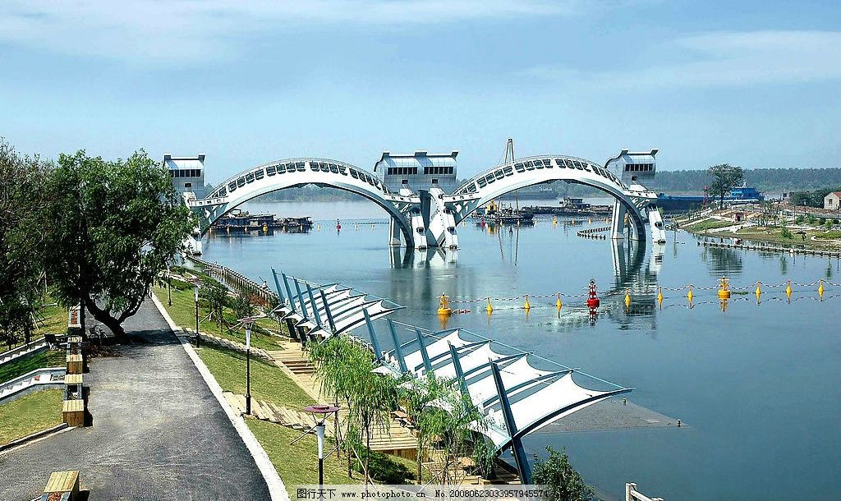
Pic. 1 The Sanchahe River Sluice

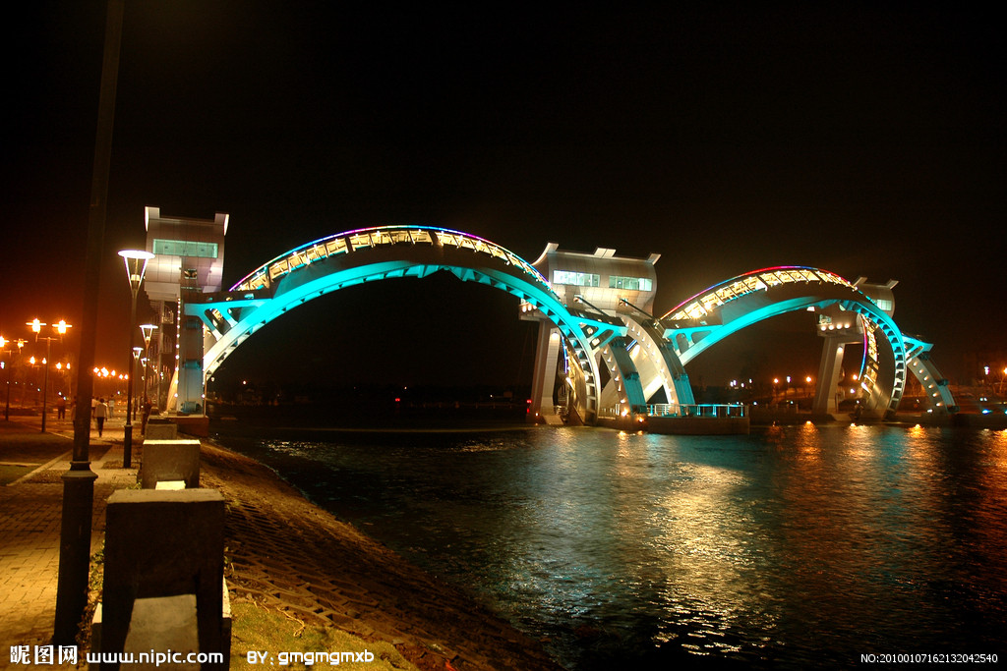
Pic. 2 The Sanchahe River Sluice
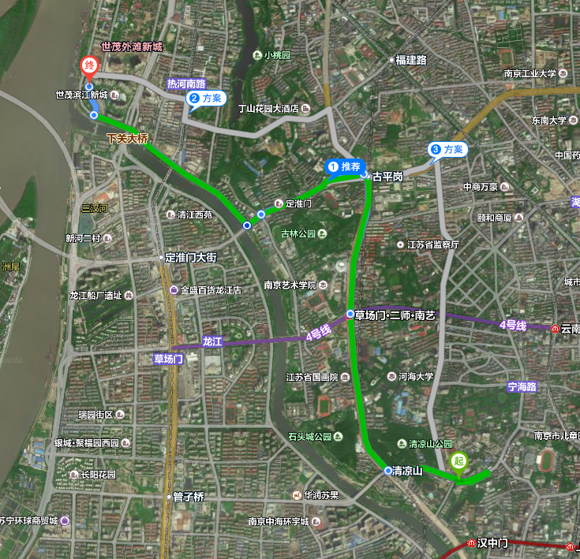
Map: From NHRI to the Sanchahe River Sluice

Guidelines for Participants

6.1 Symposium Venues:
Plenary Session (Keynotes): Multiple-function Hall (12th F, NHRI Water Resources Building, 225 Guangzhou Road, Nanjing)
Parallel Session 1: Multiple-function Hall (3rd F, R&D Hotel)
Parallel Session 2: Meeting Room 6 (3rd F, R&D Hotel)
Parallel Session 3: Meeting Room 4 (3rd F, R&D Hotel)
Parallel Session 4: Meeting Room 5 (3rd F, R&D Hotel)
Parallel Session 5: Meeting Room 3 (3rd F, R&D Hotel)
The following is a simplified map for the venue and surroundings

6.2 Registration

Our registration desk will be open for registration from 08:00-22:00 on 29 May, 2018 at the Lobby, 1F of R&D Hotel. The registration will also be open for information and help from 09:00-18:00 on 30 and 31 May, 2018.

6.3 Arrivals & Departures

6.4 Language
Plenary Session: English & Chinese (simultaneous translation)

Parallel Sessions: English

6.5 Catering

6.6 Contacts

